**EAST WEST UINVERSITY**

**Department of Computer Science and Engineering**

**Post Lab**

**Semester:** Summer’17

**Course code:** CSE 251 (2)

**Course title:** Electronic Circuits

**Experiment No:** 08

**Experiment title:** Introduction to Transistor

**Submitted to:**

Surajit Das Barman

Senior Lecturer

Department of CSE

East West University

**Submitted by:**

Kowser Mahmud Tanim

ID: 2015-2-60-062

Group No: 05

Group IDs: 2015-2-60-078, 2015-2-60-057, 2015-2-60-108

**Date of performance:** 01/08/2017

**Date of report submission:** 10/08/2017

**Experiment No:** 08

**Experiment title:** Introduction to transistor

**Objectives:**

1. Identify base, emitter and collector terminals and connections of PNP transistors.
2. Demonstrate and measure the effects on bass and reverse bias in the emitter-base circuit.

**Equipments and Components needed**

1. Power supply
2. Multimeter
3. Resistor(220KΩ and 100Ω)
4. Transistor(PNP)
5. Voltmeter
6. DC mili-ammeter and DC micro-ammeter

**Circuit Diagram:**

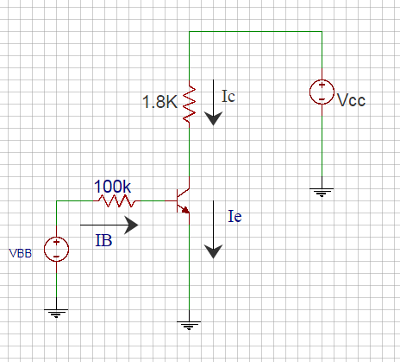

Figure 1: Circuit Diagram for measuring I-V characteristics of Transistor

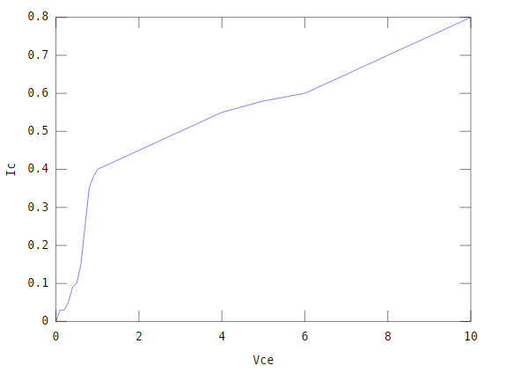

## Figure: Simulated figure in MATLAB

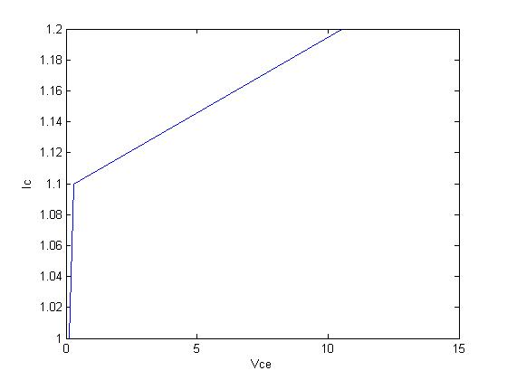

## Figure: Simulated figure in PSPICE

**Conclusion:**

From the above experiment it is easy to understand what is base, emitter and collector terminals. How transistor works.